**Linux Machine (CentOS)**

**Task 12:-** **Cent OS 9 (server/client) installation over VMware.**

a) Installing VMware Workstation.

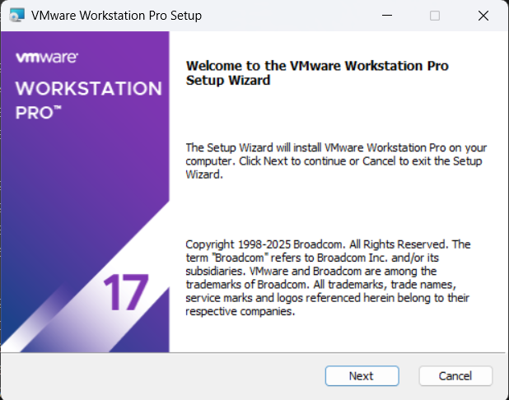

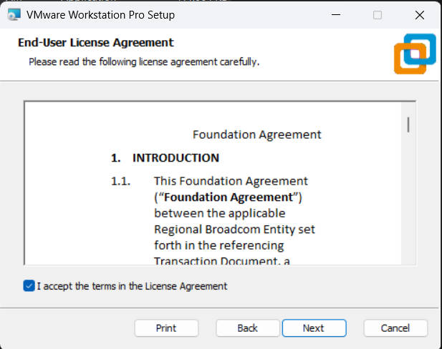

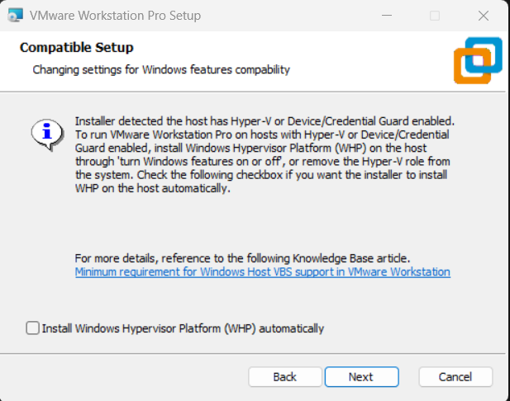

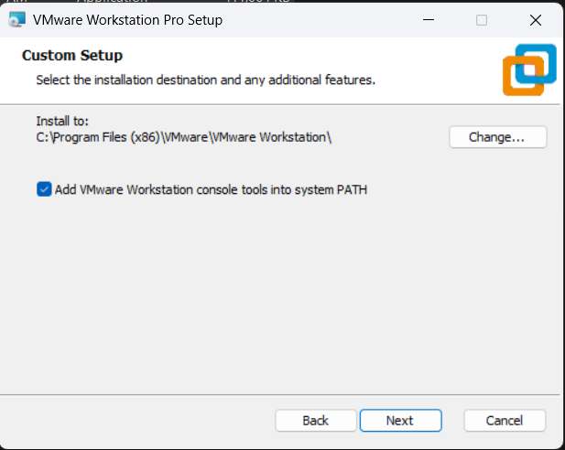

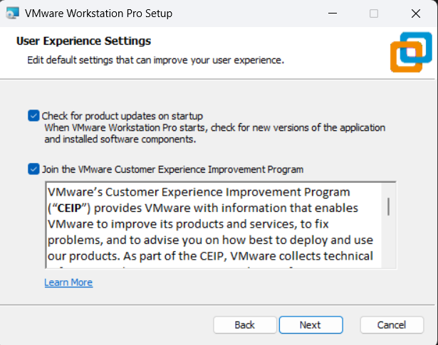

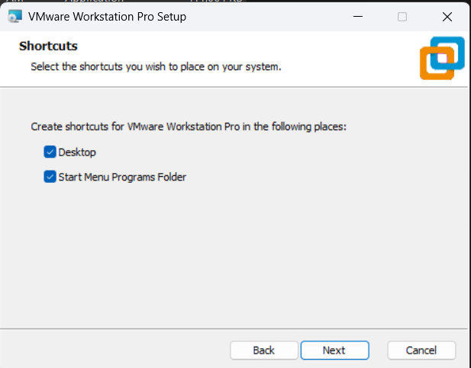

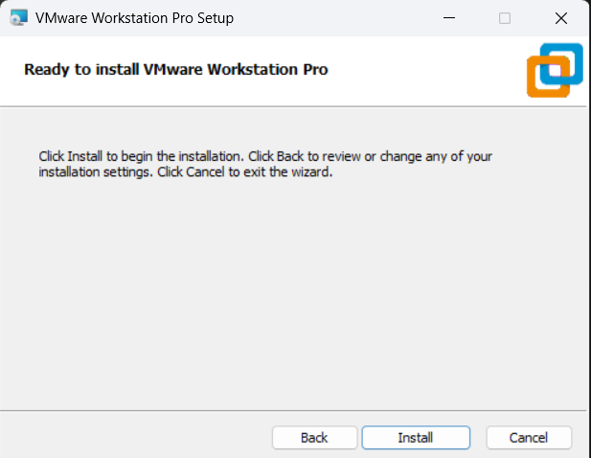

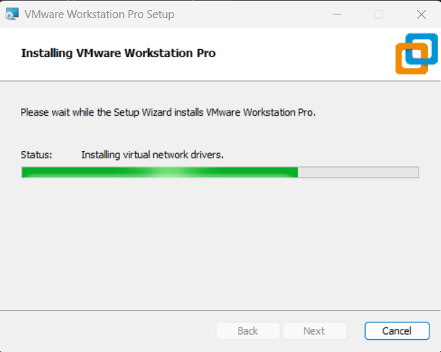

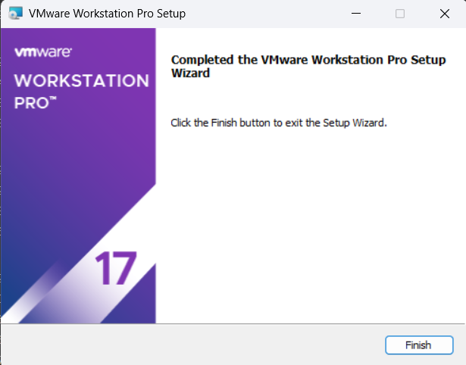

b) Creating Virtual Machine of CentOS 9.

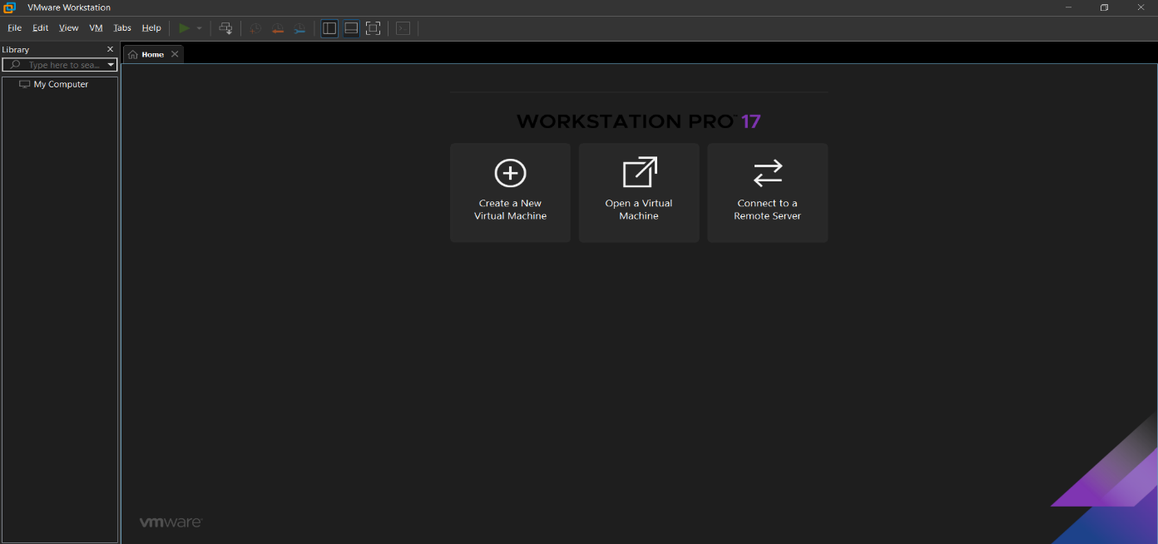

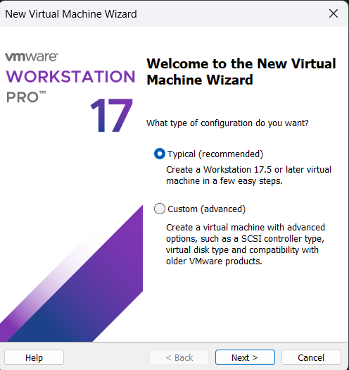

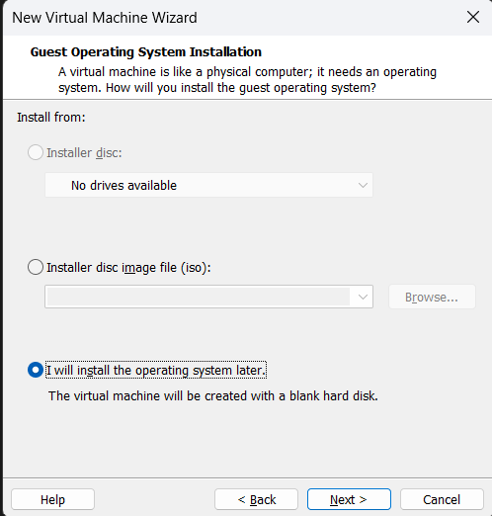

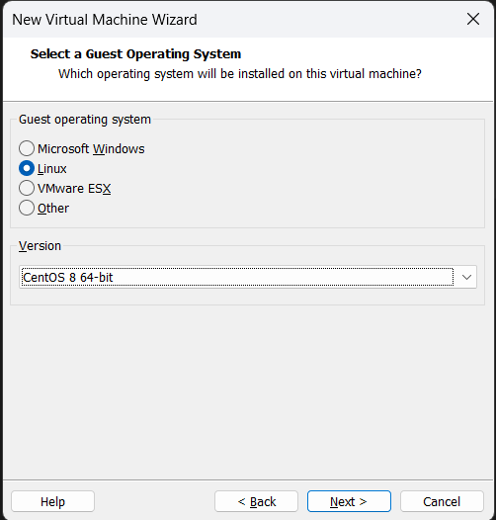

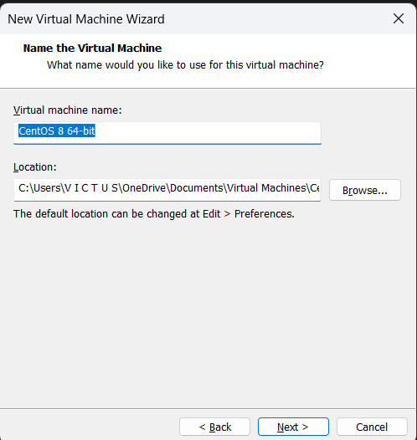

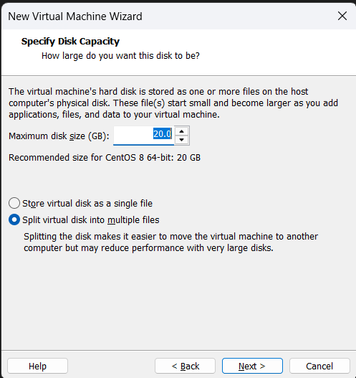

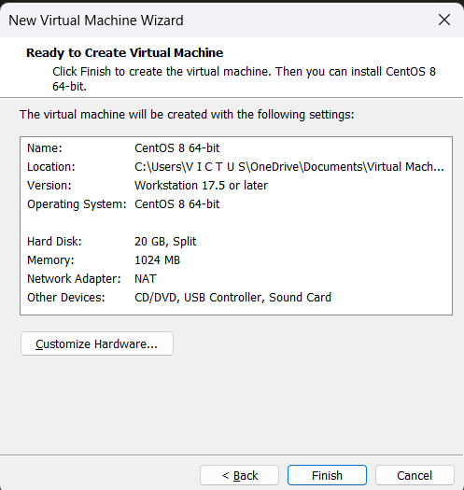

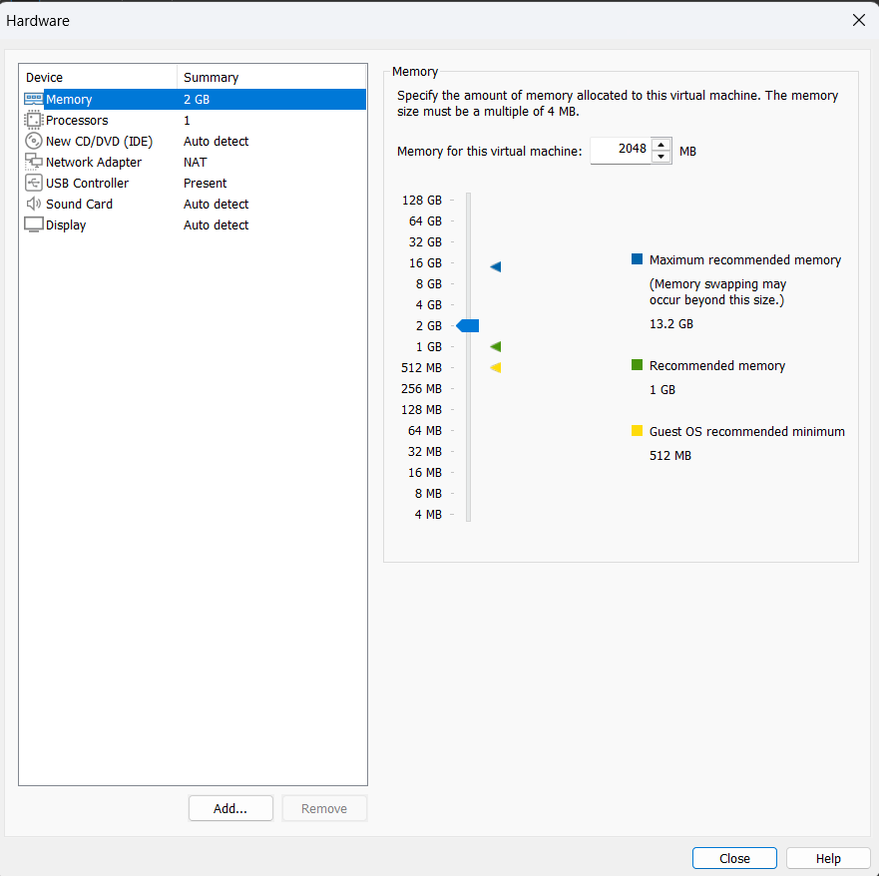

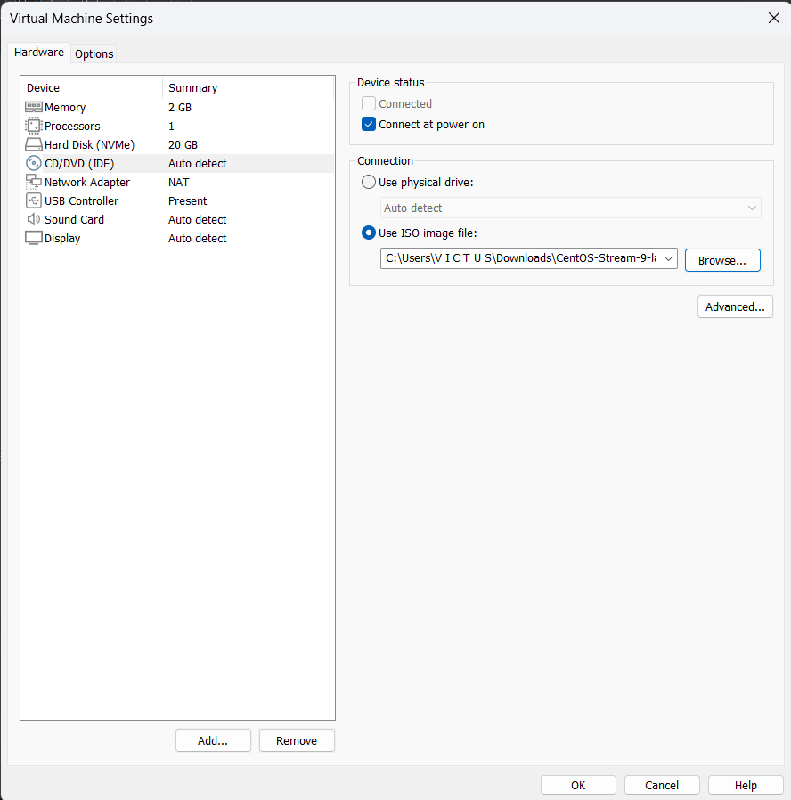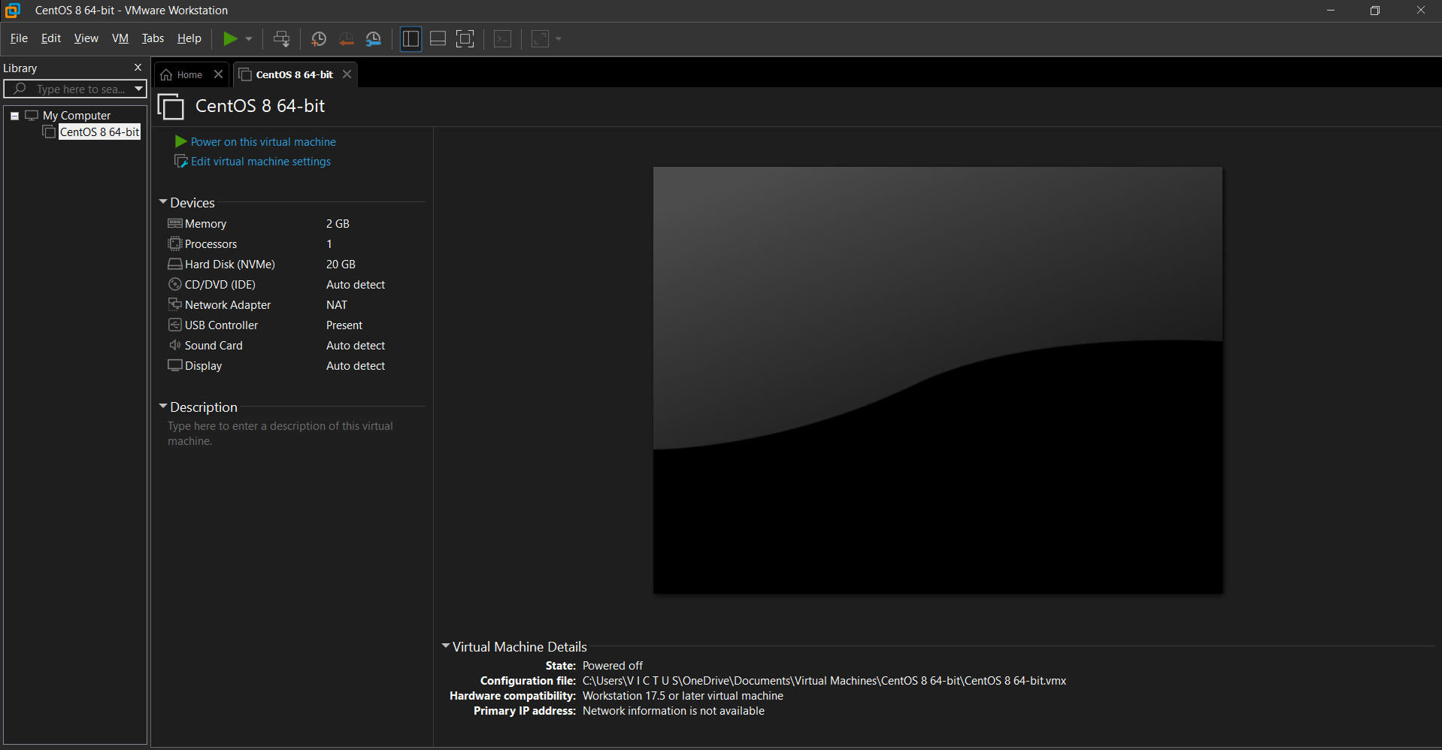

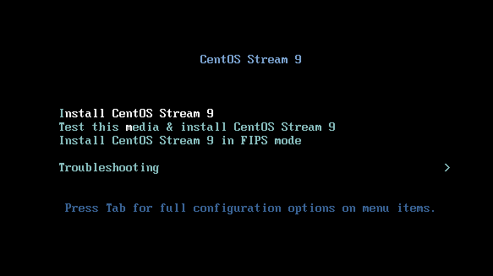

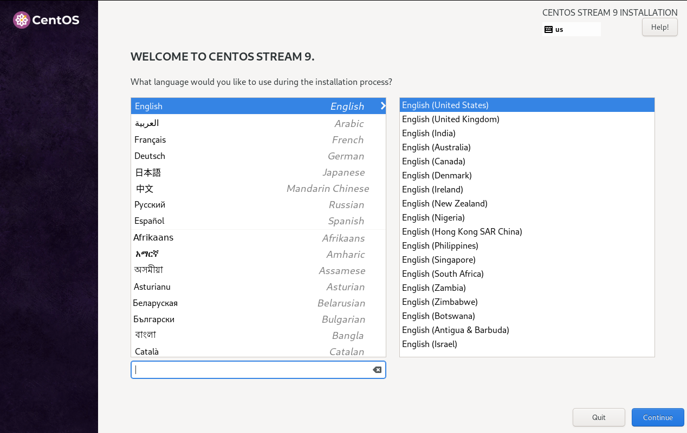

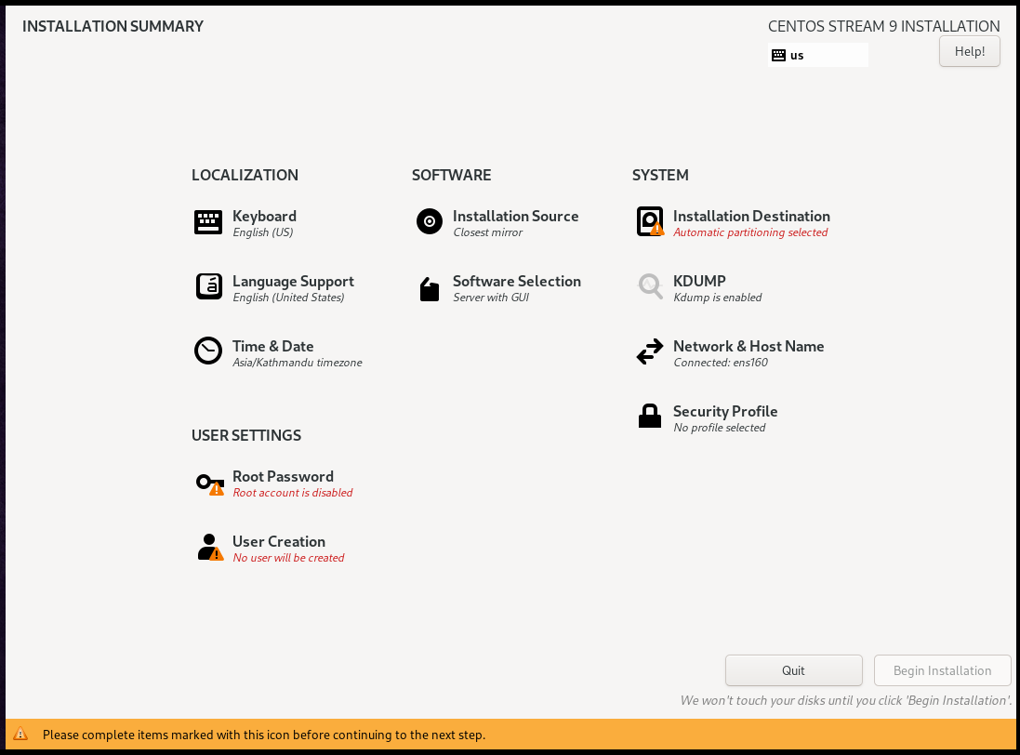

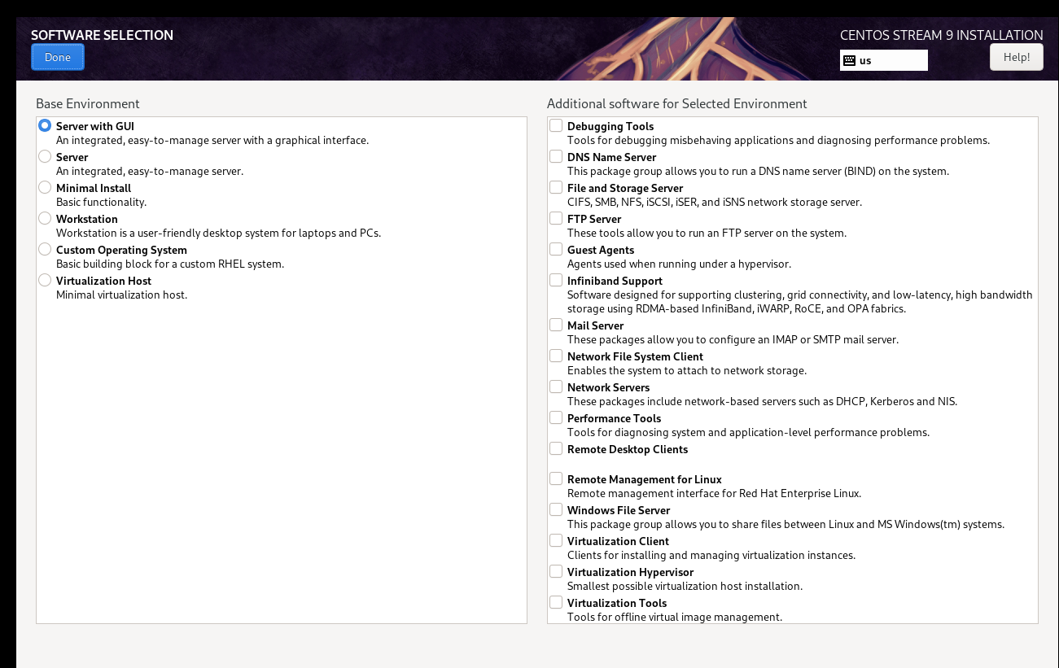

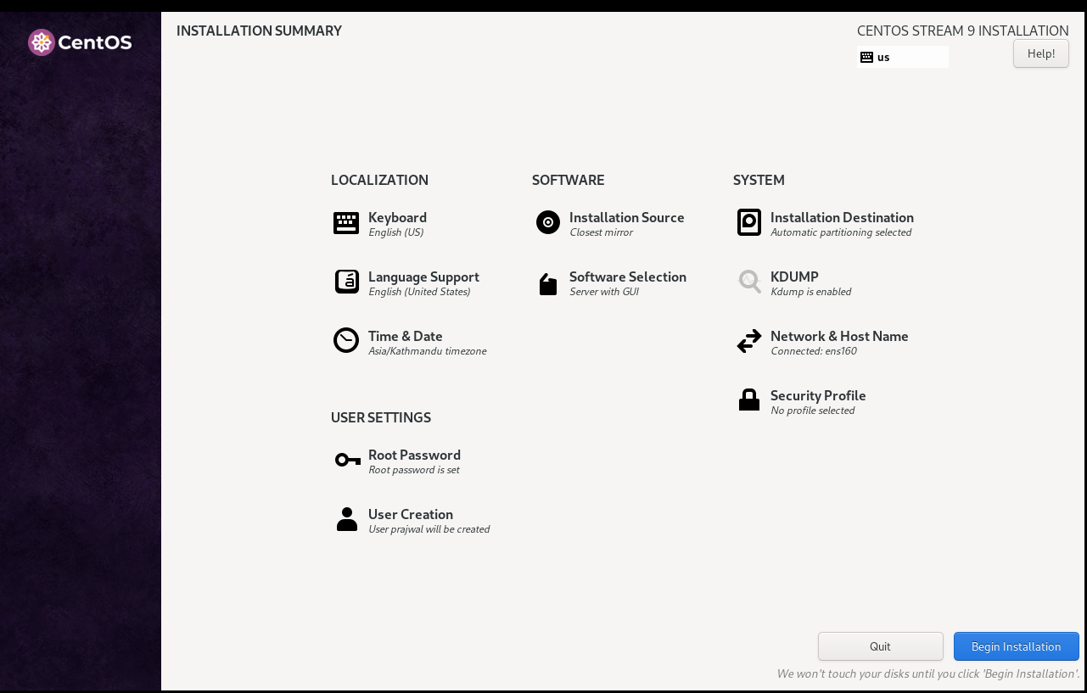

c) Assign the hostname of Linux machine as <**yourname**>**.cnlab.local.**

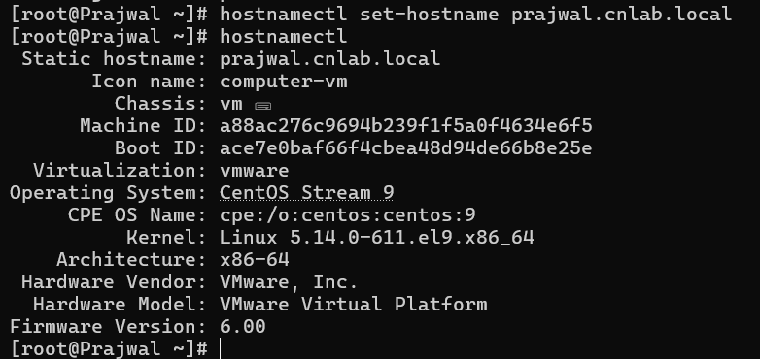

**Task 13:- Linux Fundamentals.**

a) Write brief history of Linux.

Linux was created by Linus Torvalds in 1991 as a free and open-source alternative to the proprietary Unix operating system. Linus was a student at the University of Helsinki when he started working on the project. Initially, it was a hobby for Torvalds and was intended to be a personal operating system that ran on his Intel 80386-based computer.

The first release, Linux 0.01, was made available in September 1991. It was based on the Minix operating system, a Unix-like OS used for educational purposes. Over time, Linux grew rapidly due to contributions from developers worldwide.

b) Describe briefly about the following Linux Filesystems Hierarchy:

**/boot, /root, /user, /home, /usr/bin, /bin, /user/sbin, /sbin, /usr/lib64, /lib64, /usr/lib, /lib, /dev, /etc, /media, /mnt, /opt, /proc, /tmp, /var, /run.**

**(i). /boot:-**

Contains essential files for the boot process, such as the Linux kernel and initial RAM disk (initrd). It also holds bootloader files like GRUB, which are necessary to start the system.

**(ii). /root:-**

The root user's home directory. Unlike /home, which stores user-specific files for regular users, /root is reserved for the system administrator (root).

**(iii). /user:-**

This directory is typically where user-related programs and files are stored. It is often a shared partition across multiple computers or servers. Commonly, it's seen as /usr in Linux systems.

**(iv). /home:-**

Contains home directories for regular users. Each user gets a personal subdirectory within /home (e.g., /home/username) where their personal files and settings are stored.

**(v). /usr/bin:-**

Contains essential user command binaries or programs. These programs are required for the system to operate in multi-user mode. It stores user-level executables that are not needed during boot-up.

**(vi). /bin:-**

Contains essential command binaries (e.g., ls, cp, mv, bash). These binaries are required for basic system functionality and are needed to boot and repair the system. /bin is intended to contain only the most critical programs.

**(vii). /usr/sbin:-**

Contains system administration binaries. These are executables for system maintenance and management tasks (e.g., useradd, systemctl). These commands are not generally needed by normal users but are important for system administrators.

**(viii). /sbin:-**

Similar to /usr/sbin, but contains vital system binaries that are necessary for the boot process or repair. For example, /sbin/fsck is used for file system consistency checks.

**(ix). /usr/lib64:-**

Stores 64-bit libraries for 64-bit systems. These libraries support programs that are installed in /usr/bin or other directories. This is used in systems where 64-bit applications are in operation.

**(x). /lib64:-**

Contains essential shared libraries for 64-bit binaries. These libraries are used by the programs in /bin, /usr/bin, and /sbin to perform various system functions.

**(xi). /usr/lib:-**

Contains libraries for 32-bit programs. This is the default location for libraries required by executables in /usr/bin.

**(xii). /lib:-**

Stores essential shared libraries and kernel modules required for the system to function, especially for the executables in /bin and /sbin.

**(xiii). /dev:-**

Contains device files for all hardware devices connected to the system, such as disks, printers, and terminals. These files allow programs to interact with the system's hardware.

**(xiv). /etc:-**

Stores system-wide configuration files. These files are crucial for system settings and configuration, like /etc/passwd (user account info) and /etc/fstab (filesystems mounting information).

**(xv). /media:-**

Provides mount points for removable media like CD/DVD drives, USB drives, and other external devices. For example, /media/usb could be where a USB stick is mounted.

**(xvi). /mnt:-**

Typically used for temporarily mounting filesystems, such as during system maintenance or when mounting an additional disk. This directory is commonly used for manual mounting of filesystems.

**(xvii). /opt:-**

Contains optional or third-party software packages that are not part of the core operating system. Typically, applications installed manually or from non-distribution sources are placed here.

**(xviii). /proc:-**

A virtual filesystem that provides information about the system and running processes. For example, /proc/cpuinfo shows details about the processor, and /proc/meminfo displays memory usage.

**(xix). /tmp:-**

Used to store temporary files created by various programs and processes. Files in this directory are usually cleared when the system is rebooted.

**(xx). /var:-**

Stores variable data like logs, caches, and databases. For example, /var/log contains system log files, while /var/cache contains cache files.

**(xxi). /run:-**

Contains runtime information for processes that are running. This is a temporary filesystem that is cleared upon system reboot, storing information like process IDs (PIDs), system locks, and service states.

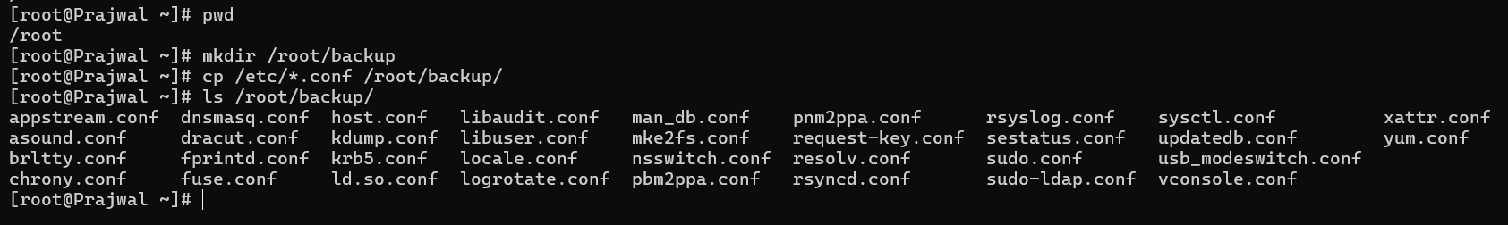c) Copy all the files that have **.conf** filename extensions inside **/etc** directory to **/root/backup** directory.

d) Create a directory **/root/selected** then move all files of **/root/backup** directory that have ‘o’ or ‘a’ as the second character of their file name to **/root/selected** directory.

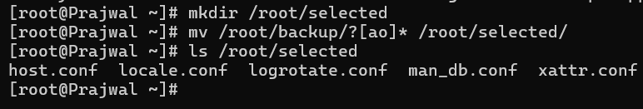

e) Remove second character with r in path /root/backup.

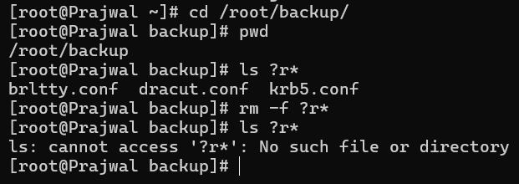

f) Remove all files and directories in path /root/backup.

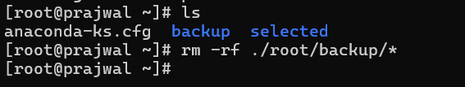

**Task 14:-** **User, Groups, Permission.**

1. 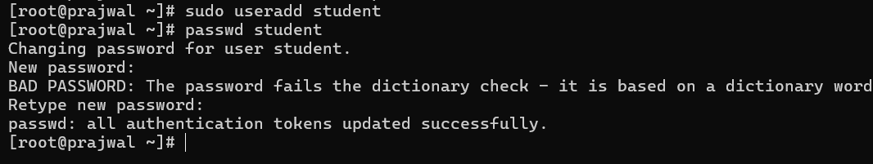Create a user named student.
2. Login from student user then create files and folders according to following tree structure. [where, d→ directory and f→ file].

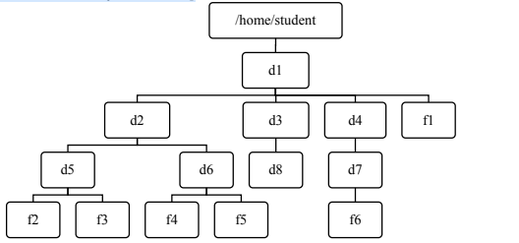

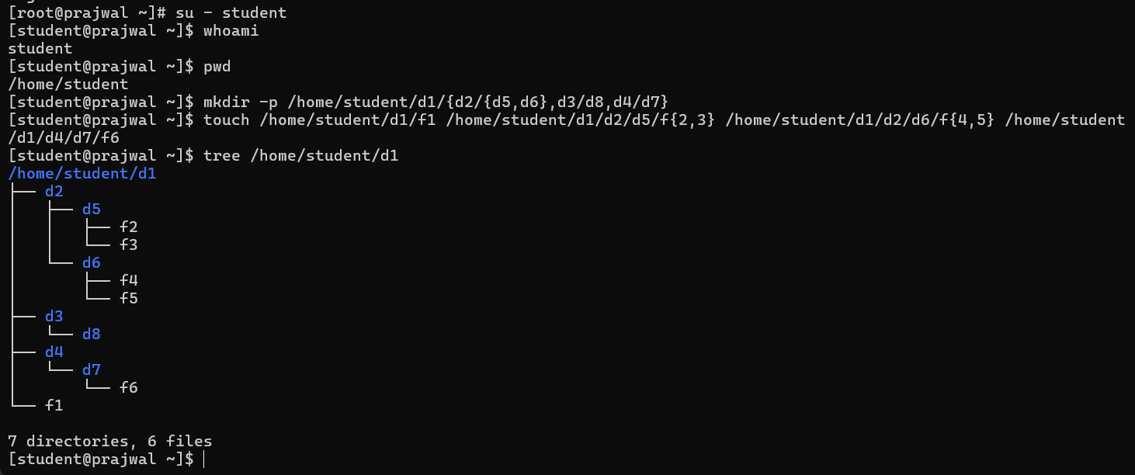

c) Change the permission of the file **f1** so that the owner will get full permission, group member will get read and execute permission and others will get read-only permissions.

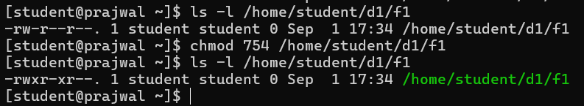

d) Change permission of the file **f2** such that the owner’s and group members will get read and write permission but others will get no permission.

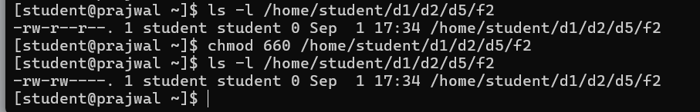

e) Change permission of directory **d3** such that all categories of users will get full permissions.

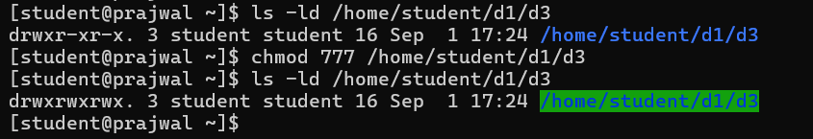

**Task 15:-** **Firewall Configuration.**

**Package:** firewalld

**Package service name:** firewalld

1. 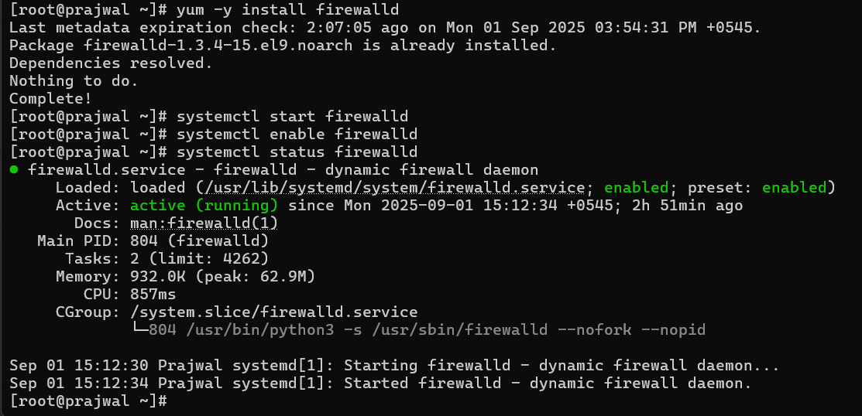Install firewalld package as well as start and enable firewall services.

b) Add the following services and ports to allow packets through the firewall.

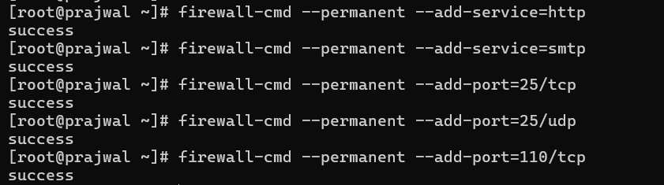[Service = http, smtp port = 25 /tcp, 25/udp, 110/tcp]

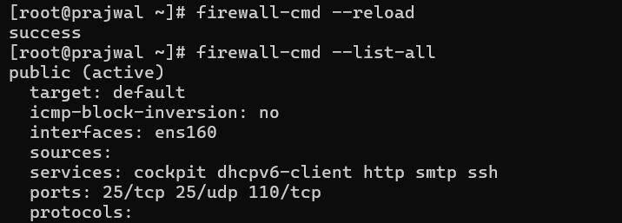

c) Remove the following services and ports to block packets through the firewall.

[Service = smtp port = 25 /tcp, 25/udp]

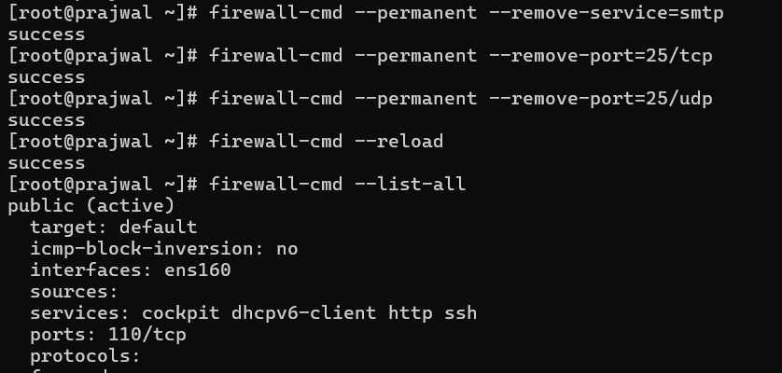

**Task 16:-** **Network Configuration (Static and Dynamic).**

Configuration file path: /etc/sysconfig/network-scripts

Main configuration file: ifcfg-ens160 or ifcfg-<ethernet name>

Service name: NetworkManager

Tool: nmclie (Network Manager command-line interface)

Local DNS configuration file: /etc/hosts.

a) Assigning IP address from DHCP server.

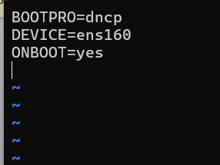

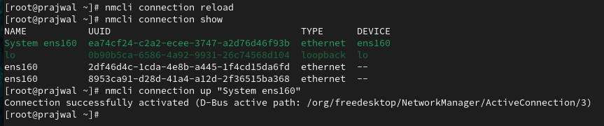

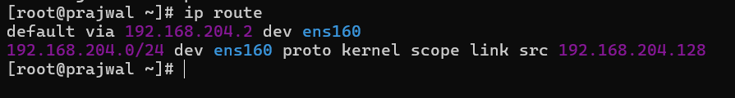b) Configure the network interface with ipv4 address <your network>.10/24. Also start and enable the respective services.

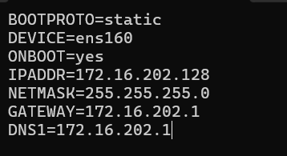

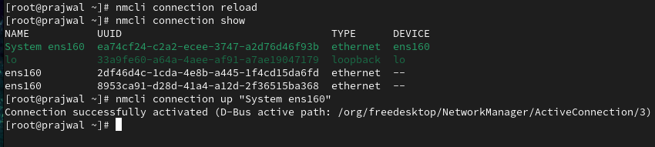

c) View the current hostname status.

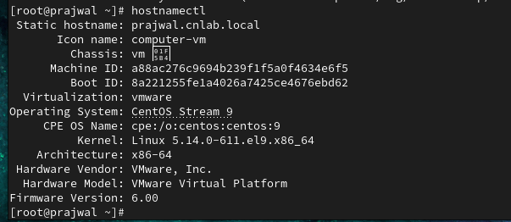

d) Resolve the hostname with your statis IP address using local DNS.

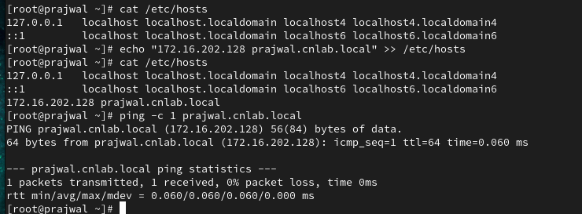

**Task 17:-** **Apache Web Server Configuration.**

**Package:** httpd

**Package service name:** httpd

**Listening port:** 80/tcp, 80/udp

**Firewall service name:** http

**Configuration files:** /etc/httpd/conf/httpd.conf;

1. Install httpd package as well as start and enable httpd services.

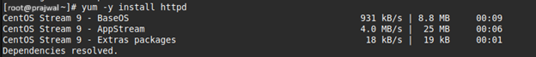

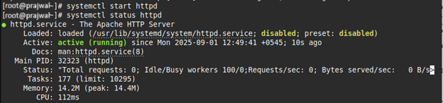

1. Allow http packets to enter through firewall.

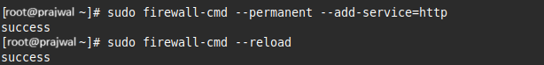

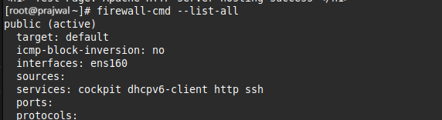

1. Set up a simple virtual host called **<yourname>.cnlab.local** with index.html placed in DocumentRoot **/var/www/html**.



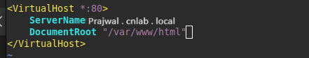

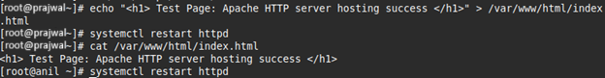

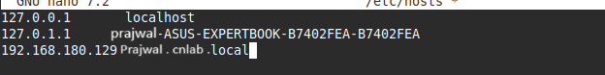

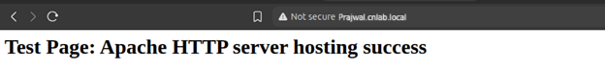

**Task 1:- Identify cable standards. Create and Test cross – over and**

**straight through cables.**

**Theory:-**

The TIA/EIA-568B color code is the most commonly used wiring standard for Ethernet cables. It defines the arrangement of wires in an RJ45 connector to ensure consistent communication between devices.

Straight Through cables:-

* It is used to connect different types of devices, such as a computer to a switch or router. Both ends of the cable use the 568B standard.

Cross over cables:-

* It is used for connecting similar devices, such as computers to computers or switches to switches. One end uses the 568B standard, while the other uses the 568A standard.

**Wiring standard:-**

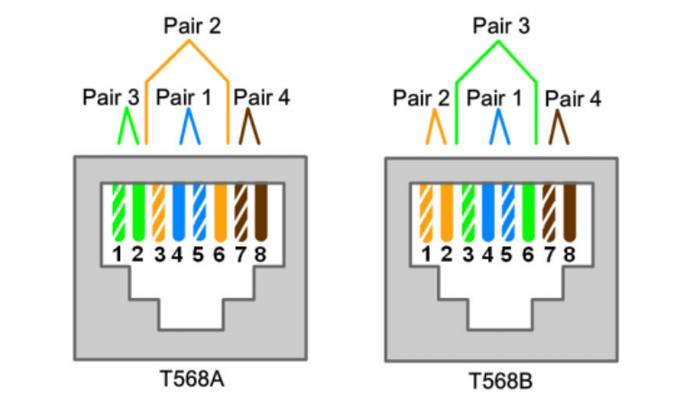

**TIA/EIA 568A color code**   **TIA/EIA 568B color code**

**1) Materials Required.**

* **UTP (Unshielded Twisted Pair) cable** – Category 5e or Category 6
* **RJ-45 connectors** (8P8C modular plugs)
* **Crimping tool** (for RJ-45)
* **Cable stripper** (or the stripping blade on the crimping tool)
* **Cable tester** (for continuity and pin-out verification)
* **Devices for testing:**
  + PC to switch (straight-through)
  + PC to PC (crossover)

**2) Preparing the Cable.**

1. Cut the UTP cable to the desired length.
2. Strip about 1 inch (2.5 cm) of the outer sheath using the stripper.
3. Untwist the four pairs of wires carefully.
4. Arrange the wires in the required order (according to TIA/EIA-568B color code).
5. Flatten the wires, trim them evenly (so all conductors are the same length).

**3) Creating a Straight-Through Cable.**

* Use TIA/EIA-568B color code on both ends.

TIA/EIA-568B order (left to right, clip facing down):-

1. White-Orange
2. Orange
3. White-Green
4. Blue
5. White-Blue
6. Green
7. White-Brown
8. Brown

**Steps:-**

1. Insert wires into the RJ-45 connector following the sequence above.
2. Push wires fully so copper contacts reach the end.
3. Insert the connector into the crimping tool and crimp firmly.
4. Repeat the same on the other end with the same order.
5. This cable connects different devices (PC → Switch, Switch → Router).

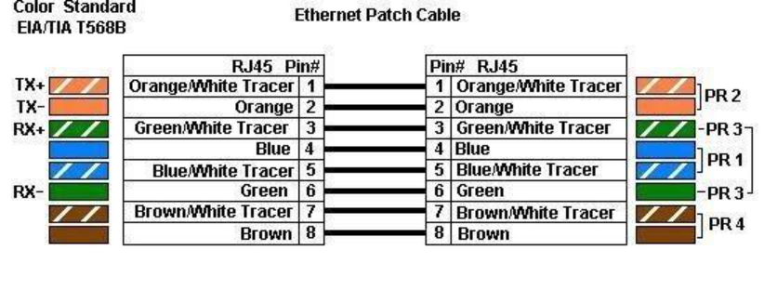

**4) Creating a Crossover Cable.**

* One end uses TIA/EIA-568B, the other uses TIA/EIA-568A.

**TIA/EIA-568A order:-**

1. White-Green
2. Green
3. White-Orange
4. Blue
5. White-Blue
6. Orange
7. White-Brown
8. Brown

**Steps:-**

1. Terminate one side as 568B (same as straight-through).
2. Terminate the other side as 568A.
3. Crimp both ends.

This cable connects similar devices (PC ↔ PC, Switch ↔ Switch, Router ↔ Router).

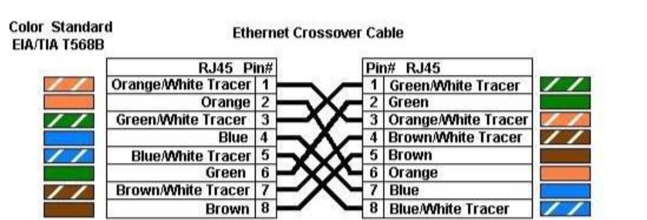

**5) Testing the Cable.**

**1. Using a Cable Tester:-**

* Plug each end into the tester’s ports.
* LEDs should light sequentially 1 → 8.
* For straight-through: both ends show the same order.
* For crossover: tester indicates crossing between pins 1↔3 and 2↔6.

**2. Using Devices:-**

* Connect the cable between devices.
* Check if link lights (LEDs) on NIC or switch ports turn ON.
* Try file sharing or pinging between devices to confirm connectivity.

**Task 2:- Create a basic network and share file and folders.**

**Theory:-**

Network sharing allows us to give other computers on the same network access to selected drives or folders. Here’s how to set it up:-

**Step 1:-** Open Network and Sharing Center.

* Go to Control Panel → Network and Sharing Center.
* This is where you can manage your network settings and enable file sharing.  
  Go to Control Panel → Network and Sharing Center.

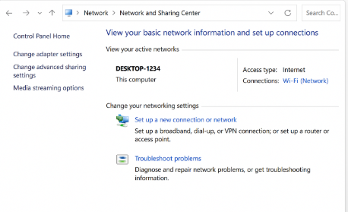

**Step 2:-** Create and Prepare a Folder for Sharing.

* Create a new folder that you want to share.
* Right-click the folder → Select Properties → Go to the Sharing tab

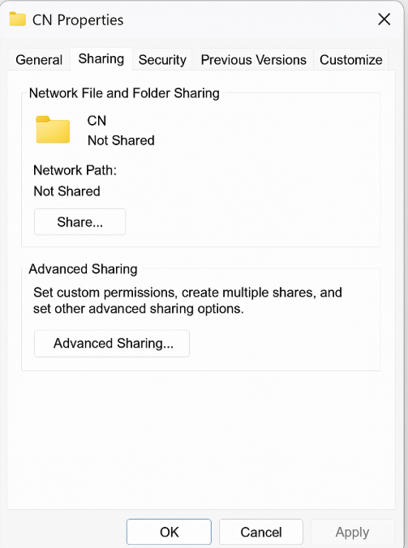

**Step 3:-** Enable Advanced Sharing.

* In the Sharing tab, click Advanced Sharing….
* Enter a Share Name so it can be identified on the network.

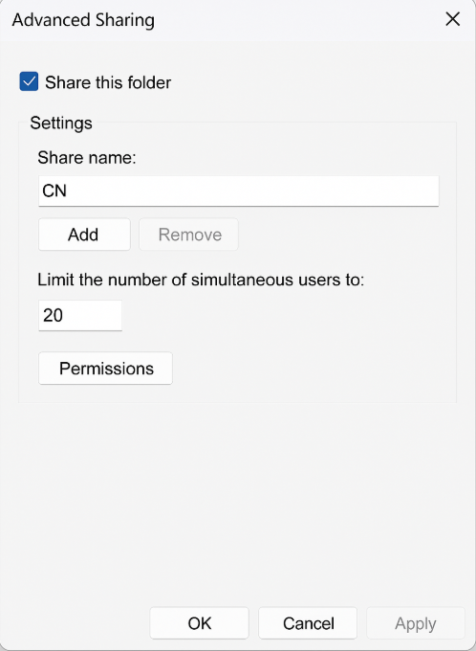

**Step 4:-** Set Permissions.

* Click on the Permissions button.
* Choose the level of access you want: Read, Change, Full Control
* Click Apply and then OK.

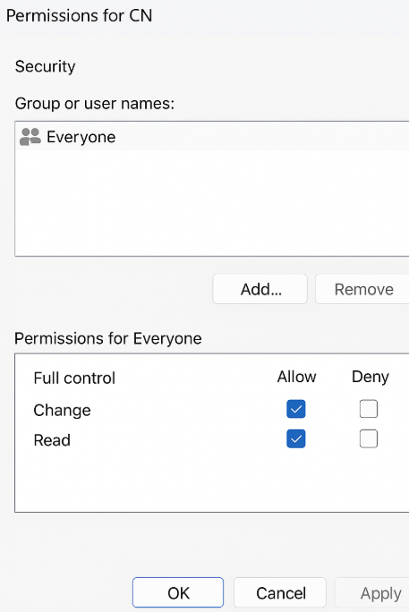

**Step 5:-** Access the Shared Folder from Another Computer.

* On another PC in the same network, press Win + R.
* Type the host computer’s name or IP address.
* You should see the shared folders.

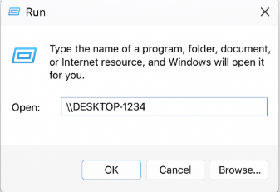

**Step 6 (Optional):-** Map as a Network Drive.

* Open File Explorer → This PC → Map Network Drive.
* Choose a drive letter.
* Enter the network path.
* Check Reconnect at sign-in.

